**SEA LEVEL RISE PREDICTION SYSTEM**

, , ,

94144@must.edu.eg

94137@must.edu.eg

94245@must.edu.eg

86346@must.edu.eg

Misr University for Science and Technology

Faculty of information Technology

**ABSTRACT -** The rise in global sea levels poses a significant environmental threat, necessitating proactive measures for coastal communities and ecosystems. This study proposes a machine learning-based approach to predict future sea level rise by utilizing historical sea level data and relevant environmental factors. The objective is to develop accurate forecasting models that enable the implementation of effective mitigation and adaptation strategies.

To achieve this objective, several regression algorithms, including linear regression, random forest, decision tree, K-nearest neighbors, lasso regression, and ridge regression, are employed to analyze the intricate relationships between sea level and contributing factors. The study focuses on enhancing the accuracy of predictions by exploring different algorithms and evaluating their performance using established metrics such as mean squared error and R-squared.

Through comprehensive analysis, the research demonstrates the predictive capabilities of the regression models and their potential to assist policymakers, urban planners, and coastal communities in making informed decisions to mitigate the adverse impacts of rising sea levels.

The machine learning-based approach presented in this study offers valuable insights into the prediction of future sea level rise. The accurate predictions provided by the models can guide decision-making processes and contribute to the development of resilient coastal areas in the face of climate change.

KEYWORDS: sea level rise; machine learning; regression algorithms; coastal communities; environmental factors

**INTRODUCTION -** Sea level rise is a pressing global concern that poses significant challenges to coastal communities and ecosystems. As the Earth's climate continues to change, understanding and predicting future sea level rise is of paramount importance for effective planning and adaptation strategies. In recent years, machine learning techniques have emerged as powerful tools for predicting sea level rise, offering improved accuracy and insights into the complex dynamics of this phenomenon.

In the current literature, several studies have explored the application of machine learning algorithms to sea level prediction. For instance, a study by the Laboratoire de Génie Côtier et Environnement (LGCE) in Plouzané, France (2021) [1], focused on using machine learning methods for sea level predictions in the upper part of a tidal estuary. While their work demonstrated the effectiveness of machine learning in a specific geographic area, our research aims to expand the scope and consider global trends and potential impacts of sea level rise.

Another relevant study by the Department of Civil Engineering at Akdeniz University, Antalya Bilim University, and the University of Oulu (2021) [2] focused on sea level prediction using machine learning techniques. However, our work goes beyond the sole application of machine learning algorithms. We integrate additional factors such as climate data, environmental parameters, and historical trends to enhance the accuracy and reliability of our predictions. By considering a wider range of influencing factors, our approach provides a more comprehensive understanding of sea level rise and its potential implications.

Furthermore, a study conducted by the Department of Civil Engineering at Universiti Tenaga Nasional (2020) [3] specifically examined sea level changes in the East Coast of Peninsular Malaysia. In contrast, our research endeavors to contribute to the field by offering a broader perspective, encompassing global sea level rise patterns. By analyzing global trends, we aim to provide valuable insights into the overall magnitude and impact of sea level rise on various regions.

While previous studies have provided important insights into the factors influencing sea-level rise, our work differentiates itself by leveraging machine learning algorithms and considering a comprehensive analysis of global sea level rise trends. By integrating various influencing factors and encompassing a broader geographical context, our predictions aim to offer a more robust understanding of sea level rise and assist in the formulation of informed decision-making and mitigation strategies.

In conclusion, this introduction has examined the current literature and highlighted the differences between our work and previous studies. By expanding the scope and incorporating additional factors, our research aims to contribute to the field of sea level prediction using machine learning techniques and provide a more comprehensive understanding of the complex dynamics of sea level rise.

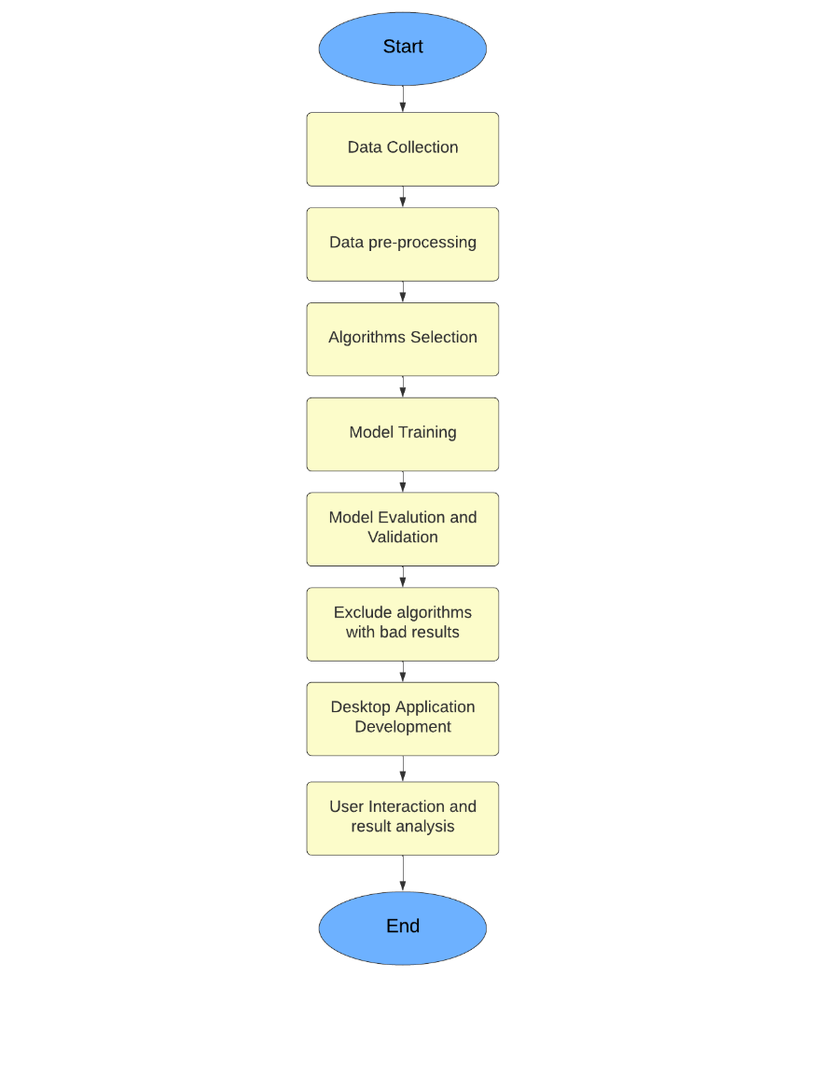METHODOLOGY -

Figure 1: Project Methodology

Data Collection: The first step involved collecting relevant data related to sea level measurements, environmental factors, and other variables that contribute to sea level rise.

Data Pre-processing: Once the data was collected, it underwent a pre-processing stage to ensure its quality and consistency. This involved cleaning the data, handling missing values.

Algorithms Selection: Next, a careful selection of regression algorithms was made to predict future sea level rise. Linear regression, random forest, decision tree, K-nearest neighbors, lasso regression, and ridge regression were among the chosen algorithms. These algorithms were selected based on their ability to handle the complexity of the problem and their suitability for analyzing the relationships between sea level and environmental factors.

Model Training: The selected algorithms were trained using the pre-processed data. This involved dividing the dataset into training and testing sets to evaluate the model's performance accurately. The models were trained to learn the patterns and relationships between the input variables (environmental factors) and the target variable (sea level) to make accurate predictions.

Model Evaluation and Validation: The trained models were evaluated and validated using established metrics such as mean squared error (MSE) and R-squared (R2). These metrics provided quantitative measures of the models' performance in predicting sea level rise. The evaluation process helped identify the algorithms that produced reliable and accurate predictions.

Exclude Algorithms with Bad Results: Algorithms that demonstrated poor performance and produced inaccurate predictions were excluded from further analysis. This step ensured that only the most robust and reliable models were considered for subsequent stages.

Desktop Application Development: To enhance usability and facilitate user interaction, a desktop application was developed. This application provided an intuitive interface for users to input relevant parameters and obtain predictions for future sea level rise based on the selected regression algorithm.

User Interaction and Result Analysis: Users interacted with the developed desktop application, providing input and exploring the predicted sea level rise scenarios. The results were analyzed to gain insights into the potential impacts of rising sea levels and inform decision-making processes related to mitigation and adaptation strategies.

RESULTS -

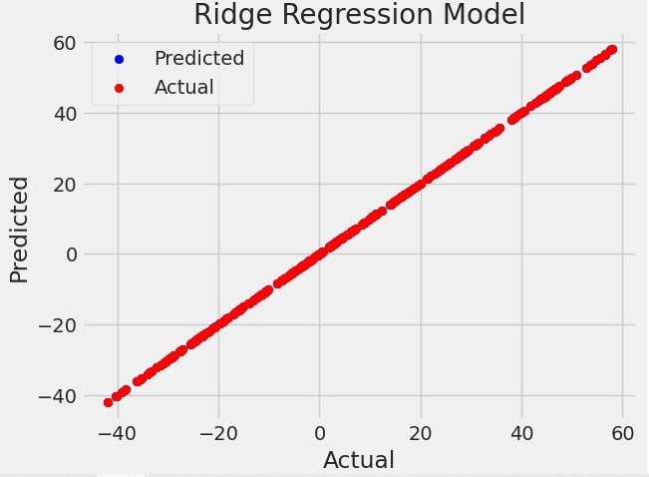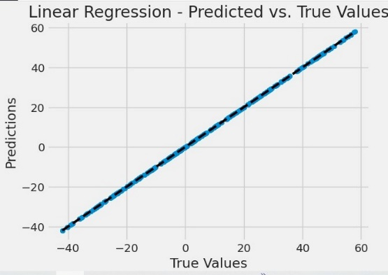

Figure 3:linear regression predicted vs true values

Figure 2: Ridge Actual vs predicted

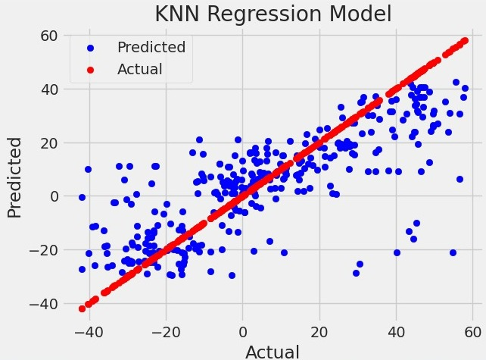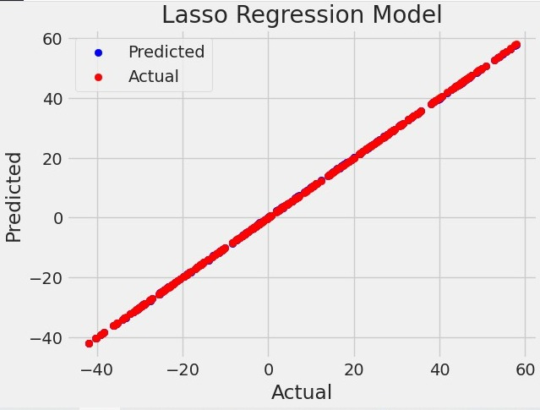

Figure 5: KNN Actual vs Predicted

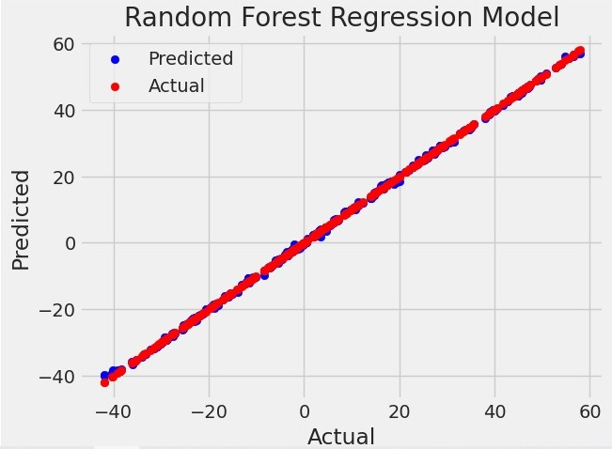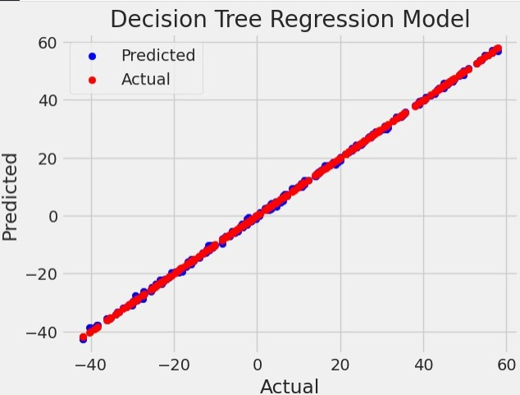

Figure 6: Decision Tree Actual vs predicted

Figure 7: Random Forest Actual vs predicted

Figure 4: Lasso Actual vs predicted

Table 1: MSE, R2 for all algorithms

|  |  |  |
| --- | --- | --- |
| Algorithm | Mean Square Error | R2 |
| Linear regression | 1.25050271257065E | 1 |
| Random Forest Regression | 0.0831380939999992 | 0.999876368586016 |
| Decision tree Regression | 0.12162697089947 | 0.999819133279735 |
| K-Nearest Neighbors Regression | 266.851836101587 | 0.6031750520857 |
| Ridge Regression | 0.00025587564459585865 | 0.999999619497318 |
| Lasso Regression | 0.009603885490539671 | 0.9999857184368104 |

DISCUSSION - In summary, the results of this study demonstrate the effectiveness of the linear Regression [4], Random Forest Regression [5], Decision Tree Regression [6], Ridge Regression, and Lasso Regression [7] models in predicting sea level rise. These models achieved accurate predictions and strong correlations with the actual sea level values. However, the K-Nearest Neighbors Regression [8] model exhibited less accurate results. It is important to consider the simplifications made in the methodology and explore further improvements to enhance the accuracy and robustness of sea level predictions.

CONCLUSION - In conclusion, this study utilized machine learning techniques to predict future sea level rise, considering various environmental factors. The results demonstrated the effectiveness of the Random Forest Regression, Decision Tree Regression, Ridge Regression, and Lasso Regression models in accurately predicting sea level rise. However, the K-Nearest Neighbors Regression model exhibited limitations in its predictive performance.

Future works could focus on expanding the dataset, including more diverse environmental factors, and exploring advanced machine learning techniques to further improve the accuracy of sea level predictions. Additionally, integrating climate change scenarios and assessing the impacts of sea level rise on specific coastal regions would be valuable for comprehensive planning and decision-making.

ACKNOWLEDGEMENT

We would like to thank Dr. Ahmed Fouad and our Teacher Assistants TA / Eng. Mohamed omar and TA / Eng. Mariam fared for their contributions and support.

REFERNCES

1. Guillou, N., & Chapalain, G. (2021). Machine learning methods applied to sea level predictions in the upper part of a tidal estuary. Oceanologia, 63(4), 531-544.
2. Tur, R., Tas, E., Haghighi, A. T., & Mehr, A. D. (2021). Sea Level Prediction Using Machine Learning. Water, 13(24), 3566.
3. Lai, V., Malek, M. A., Abdullah, S., Latif, S. D., & Ahmed, A. N. (2020). Time-series prediction of sea level change in the east coast of Peninsular Malaysia from the supervised learning approach. *Int. J. Des. Nat. Ecodyn*, *15*(3), 409-415.
4. Su, X., Yan, X., & Tsai, C. L. (2012). Linear regression. Wiley Interdisciplinary Reviews: Computational Statistics, 4(3), 275-294.
5. Rigatti, S. J. (2017). Random forest. Journal of Insurance Medicine, 47(1), 31-39.
6. Xu, M., Watanachaturaporn, P., Varshney, P. K., & Arora, M. K. (2005). Decision tree regression for soft classification of remote sensing data. Remote Sensing of Environment, 97(3), 322-336.
7. Owen, A. B. (2007). A robust hybrid of lasso and ridge regression. Contemporary Mathematics, 443(7), 59-72.
8. Kohli, S., Godwin, G. T., & Urolagin, S. (2021). Sales prediction using linear and KNN regression. In Advances in Machine Learning and Computational Intelligence: Proceedings of ICMLCI 2019 (pp. 321-329). Springer Singapore.